**Observation**:-

Name: Ankita Sahoo

Regd. No: 24C219A50

C:/Iter/Desktop/24C216A13/NOT_01.VHD

SIMULATION OF NOT GATE

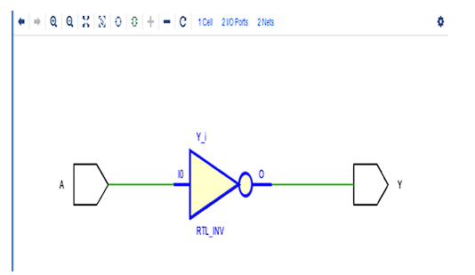

SCHEMATIC OF NOT GATE

**Observation**:-

Name: ANKITA SAHOO

Regd. No: 24C219A50

SCHEMATIC OF AND GATE

**Observation**:-

Name: ANKITA SAHOO

Regd. No: 24C219A50

SIMULATION OF NAND GATE

SCHEMATIC OF NAND GATE